Please ensure you revise THIS text not your originally submitted file
Immune Cell Infiltration and Clinical Significance of Angiogenesis-related Genes in Lung Adenocarcinoma

Qi Zhao¹, Wei-Xing Ren², Shuping Gao³ and Nan Mu³

¹Department of Thoracic Surgery, the Fourth Hospital of Hebei Medical University, Shijiazhuang, P.R. China;
²Hebei Medical University, Shijiazhuang, P.R. China;
³Department of Pharmacy, the Fourth Hospital of Hebei Medical University, Shijiazhuang, P.R. China

Correspondence to: Shuping Gao, Department of Pharmacy, 12 Jiankang Road, Shijiazhuang, Hebei 050011, P.R. China. Tel.: +86 031186095355, e-mail: gsp@hebmu.edu.cn

Running title: Signature of Angiogenesis-related Genes in Lung Adenocarcinoma
Section:
Abstract. Background/Aim: Angiogenesis is one of the hallmarks of cancer. However, the role of molecular subtypes of angiogenesis-associated genes (AAGs) in the tumor immune microenvironment (TIME) of lung adenocarcinoma (LUAD) remains unclear. Materials and Methods: The expression of AAGs in patients with LUAD were studied. Consensus clustering was performed to identify new AAG-associated molecular subgroups. The TIME and immune status of the subgroups were analyzed. Functional enrichment analysis was performed on the differentially expression genes among the clustered subgroups to analyze their relationship with AAGs. Furthermore, a prognostic risk model and clinical nomogram associated with survival time were constructed. Risk scores of drug sensitivity, immune checkpoint molecules, tumor mutational burden, and tumor cell stemness were analyzed. Finally, a series of in vitro experiments were performed to investigate the role of dickkopf WNT signaling pathway inhibitor 1 (DKK1) in LUAD. Results: Two molecular subgroups with significantly different survival rates and TIME were identified. Immune checkpoint scores were higher in the subgroup with a worse prognosis. Moreover, differentially expressed genes were enriched in cell-cycle regulation, protein metabolism, and the immune microenvironment. The risk model and clinical nomogram constructed based on AAGs accurately predicted the prognosis of patients with LUAD. Patients with high-risk scores were less sensitive to chemotherapy but more sensitive to immunotherapy. DKK1 was highly expressed in basal cells and luminal cells. In addition, the knockdown of DKK1 reduced LUAD cell proliferation, invasion, and migration. Conclusion: Models based on AAGs can play an important role in predicting LUAD prognosis and immunotherapy effects. We further characterized the angiogenesis of TIME and studied the AAG DKK1. Our findings provide a theoretical basis for antitumor strategies targeting angiogenesis.

Key Words: Lung adenocarcinoma, angiogenesis-associated genes, immune infiltration, prognosis.

Lung cancer accounts for most cancer-related deaths worldwide (1). Lung adenocarcinoma (LUAD) is the most common pathological form of lung cancer, and the personalized treatment of LUAD is garnering increasing attention in the clinical setting (2, 3). Despite significant advances in the diagnosis, treatment, and prognosis of LUAD, the long-term survival rate remains low (4, 5). Therefore, there is an urgent need to elucidate effective molecular biomarkers for improved targeted therapy and prognosis prediction in patients with LUAD.
Angiogenesis is one of the hallmarks of cancer that affects the extracellular milieu of tumors via the regulation of oxygen, nutrients, and growth factors supplied to cancer cells (6, 7). The development and growth of tumors are significantly influenced by angiogenic factors that are often overexpressed in various cancer types (8). The overexpression of angiogenesis-associated genes (AAGs) has been associated with poor prognosis in many types of tumors, such as urothelial carcinoma and bladder cancer (9). Therefore, the inhibition of angiogenesis has become a non-negligible targeted therapeutic option, especially for tumors that do not respond well to conventional therapeutic approaches (10). However, the role of AAGs in LUAD remains unexplored. By understanding the molecular characteristics of AAGs, new treatment strategies can be developed to improve the clinical symptoms of LUAD.
In this study, we systematically analyzed AAGs in LUAD. A novel molecular subtype was identified based on AAGs to predict the prognosis of patients with LUAD and the immune status of the tumor microenvironment. Additionally, we constructed a risk score model based on AAGs to predict the clinical outcomes of patients with LUAD. Furthermore, we also conducted a localization study on prognostic genes in LUAD and explored the possible molecular mechanisms to develop a personalized treatment for LUAD. The gene-expression profiles and the corresponding clinical datasets of LUAD were collected from The Cancer Genome Atlas (TCGA)

Materials and Methods
Data collection. The gene-expression profiles and the corresponding clinical datasets of LUAD were collected from TCGA)
(https://portal.gdc.com). Samples with no survival time were removed and a final 504 patients were included in the study. A total of 36 AAGs were obtained from The Molecular Signatures Database (https://www.gsea-msigdb.org/gsea/msigdb) for the analysis. The Gene Expression Omnibus (GEO) database GSE72094 was used to obtain a validation cohort (n=398). Single-cell sequencing was performed on the GSE117570 dataset (comprising two LUAD samples and two normal samples).

Consensus cluster analysis of AAGs. The protein–protein interaction (PPI) network of the 36 AAGs was obtained using STRING (https://cn.string-db.org/),Clustering analysis was performed using ConsensusClusterPlus (11), with agglomerative partition around medoids clustering set at 1−Pearson correlation distance and resampling of 80% of the samples iterated 1,000 times to ensure the stability of the classification. The optimal number of clusters was obtained using a distribution curve. Furthermore, the overall survival (OS) according to the three AAG clusters was evaluated using the Kaplan–Meier method.

Determination of differentially expressed genes (DEGs) and construction of gene clusters. Immune and stromal scores for patients of the TCGA LUAD cohort (n=504) were calculated based on their expression profiles. Immune cell infiltration was quantified using ESTIMATE algorithm (12). DEGs in the three AAG clusters were identified using the “limma” package in the R software (using p<0.01, false-discovery rate<0.01, and log fold change >2). Functional enrichment analysis of differential genes was performed using Kyoto Encyclopedia of Genes and Genomes (KEGG) and Gene Ontology (GO) analysis. The DEGs associated with survival were determined by univariate Cox regression analysis, and patients with LUAD were classified into different clusters according to the selected DEGs.

Establishment of risk models. Based on prognostic DEGs, the least absolute shrinkage and selection operator (LASSO)–Cox method was used to perform 10 rounds of cross-validation, and the best model was obtained. The R package “glmnet” was used to integrate the survival time, survival status, and gene expression, and patients with LUAD were divided into high-risk and low-risk groups accordingly. In addition, the area under the receiver operating characteristics curve was calculated. The relationship between risk scores and clinical characteristics was assessed and validated using the GSE72094 cohort.

Establishment of a nomogram. The risk model was analyzed based on different clinical characteristics. A nomogram with risk scores and other clinicopathological factors was then constructed. Moreover, the OS at 1, 3, and 5 years of patients with LUAD was predicted. Calibration curve analysis and decision curve analysis were performed to verify the clinical reliability of the established nomogram.

Single-cell sequencing. The single-cell dataset GSE117570 of LUAD was downloaded from the GEO database, and two tumor samples and two normal samples were selected. Cell quality control (QC), sample normalization and principal component analysis (PCA) were performed via the R package “Seurat”. Cluster identification, gene marker screening, and cluster renaming were performed with the R package “SCHCL”. DEGs in tumor samples were identified and compared with those of normal samples.

RNA extraction of tissue samples and real-time quantitative polymerase chain reaction (RT-qPCR). LUAD tumor tissue and normal tissue were collected from 20 patients with LUAD at the Fourth Hospital of Hebei Medical University. Written consent was obtained from each subject, and the study protocol met the standards set out in the Declaration of Helsinki. The research method was also approved by the Ethics Committee of the Fourth Hospital of Hebei Medical University (Ethics number: 2022KY242).
Total RNA was extracted from the collected specimens with TRIzol (Invitrogen, Carlsbad, CA, USA) and the RNA was reverse-transcribed to cDNA using a Uni RT&qPCR Kit (Biosharp, Hefei, P.R.C) for RT-qPCR (ABI QuantStudio 3, Waltham, MA, USA). We used glyceraldehyde 3-phosphate dehydrogenase (GAPDH) as an internal reference and calculated the relative gene-expression levels using 2^{−ΔΔCT} then visualized the data using GraphPad Prism 9.0 (GraphPad Software, San Diego, CA, USA). The primers for dickkopf WNT signaling pathway inhibitor 1 (DKK1) were 5’-GACAACTACCAGCCGTACCC-3’ and 5’-TGACAACTACCAGCCGTACC-3’, and for GAPDH were 5’-CACCATCTTCCAGGAGCGAG-3’ and 5’-TGAGAAGGCTGGGGCTCATTT-3’.

Cell culture and reagents. Human NCI-1299 cell line was purchased from Procell Life Science & Technology Co., Ltd (Wuhan, P.R.C). NCI-H1299 cells were maintained in Dulbecco’s modified Eagle’s medium (DMEM) (Gibco, Carlsbad, CA, USA) supplemented with 10% fetal bovine serum (FBS). The cells were cultured in a humidified incubator at 37°C with 5% CO₂.

DKK1 knockdown. NCI-H1299 cells were seeded at a density of 3×10⁵ in a 60 mm dish. After 24 h of incubation, the medium was replaced with fresh medium. The NCI-H1299 cells were then transfected with DKK1 short interfering RNAs (siRNAs) or control-siRNA (GenePharma, Suzhou, P.R.C.), using Lipofectamine 2000 transfection reagent (Invitrogen). The sequences of DKK1 siRNAs used were 5'CCTGTCCTGAAAGAAGGTCAA3' (si1) and 5'GCCAGTAATTCTTCTAGGCTT3' (si2) and5'CGGTTCTCAATTCCAACGCTA3' (si3).

Cell counting kit-8 analysis. NCI-H1299 cells transfected or not with DKK1 siRNA were digested after reaching 90% confluency, and the cells were then inoculated into 96-well culture plates at 5,000 cells/well and five wells each. Thereafter, the cells were cultured in an incubator at 37°C with 5% CO₂ and analyzed at 0, 24, 48, and 72 h using a CCK-8 cell counting kit (Biosharp, Hefei, P.R.C).

Wound-healing test. Native cells or cells transfected with DKK1 siRNA were seeded in 6-well plates and cultured for 24 h. The surface of the culture was then scraped with a 200 μl pipette tip and then cleaned with serum-free medium to remove cell debris. The cells were then photographed every 24 h, and regions of migration were evaluated using ImageJ software (National Institutes of Health, Bethesda, MA, USA).

Transwell migration assay. DKK1 siRNA-transfected and non-transfected NCI-H1299 cells (4×10⁴) were seeded in the upper chamber of a Transwell chamber (Corning Inc., Corning, NY, USA) in DMEM without FBS; the lower chamber was filled with DMEM containing 10% FBS. After 24 h of incubation, the cells were fixed for 20 min with 4% paraformaldehyde and stained with 1% crystal violet. The cells were removed from the upper chamber, photographed, and counted using ImageJ software (National Institutes of Health).

Colony-formation assay. DKK1 siRNA-transfected and non-transfected NCI-H1299 cells were seeded in 6-well plates at a density of 500 cells per well and cultured at 37°C for 1 week. The plates were then washed with phosphate-buffered saline and fixed with 4% paraformaldehyde for 30 min. Subsequently, the plates were stained using 0.1% crystal violet and the colonies were counted using ImageJ software (National Institutes of Health).

Statistical analysis. All bioinformatics analyses were carried out using R 4.2.1 software. All p-values are two-sided, and the results were considered statistically significant when the p-values were less than 0.05. Differences between groups was analyzed using the Wilcoxon test. Kruskal–Wallis and one-way analysis of variance were used for differential analysis among three groups (13). Correlation tests were performed using Spearman analyses. Survival curves were drawn using the log-rank and Kaplan–Meier tests. The 95% confidence intervals and hazard ratios were computed using the univariate Cox regression model. Experimental data were analyzed using GraphPad Prism 9.0 (GraphPad Software) for Windows. All cell experiments were repeated three times.

Results
Consensus cluster analysis of AAGs. The expression of 36 AAGs in tumor and normal tissues was analyzed using the TCGA database. The protein–protein interaction network of the 36 AAGs is shown in Figure 1A. Cytoscape analysis was used to analyze the correlation between the 36 AAGs, Network analysis was performed using Cytoscape's MCOD and cytoHubba plugins to mine hub genes in the PPI network and the top 10 genes were identified (14) (Figure 1B).
The subsequent univariate Cox survival analysis revealed nine prognostic AAGs in LUAD samples (Figure 2A), namely periostin (POSTN), stanniocalcin 1 (STC1), lipoprotein lipase (LPL), cyclin D2 (CCND2), collagen type V alpha 2 chain (COL5A2), serpin family A member 5 (SERPINA5), jagged canonical Notch ligand 1 (JAG1), msh homeobox 1 (MSX1), and vitronectin (VTN), Patients with LUAD were grouped using a consistent clustering approach. Optimal group stability was determined at k=3 (Figure 2B), with 178 patients in cluster C1, 240 patients in C2, and 86 patients in C3. The expression levels of these nine prognostic AAGs in the three clusters were visualized using a heat map, and the expression levels were significantly different (Figure 3A). Finally, we compared the OS for the three clusters, revealing that those patients in C1 had a better prognosis (Figure 3B). These results suggest that patients with LUAD were successfully classified according to three AAG-based molecular subtypes with different survival properties.

Identification of DEGs and construction of gene clusters. We used immunological methods to study the difference between the three AAG clusters. The ESTIMATE algorithm revealed that stromal and estimate scores of LUAD patients in C1 were significantly higher than those for C2 and C3, while patients in C2 had significantly higher immune scores (Figure 4A). This illustrates the possibility that differences in the immune microenvironment contribute to the different prognostic outcomes. We investigated the differences in DEGs between the three AAG clusters and the possible signaling mechanisms through functional enrichment analysis. A total of 544 DEGs were detected, of which 262 genes were down-regulated and 230 genes were up-regulated (p<0.01, false-discovery rate<0.01, and log fold change>2) (Figure 4B).
KEGG enrichment analysis reported enrichment in the phosphatidylinositol-4,5-bisphosphate 3-kinase (PI3K)–AKT serine/threonine kinase 1 (AKT) signaling pathway, extracellular matrix–receptor interaction, focal adhesion, amongst others (Figure 5A). The GO analysis revealed enrichment in the extracellular region, regulation of protein activation cascade, regulation of complement activation and regulation humoral immune response (Figure 5B).
In order to further explore the potential biological function of the AAG subtypes in LUAD, the limma R package was used to identify the DEGs among the three clusters (log-rank test, p<0.001), and 544 genes were obtained. Based on the DEGs, a consensus clustering method was used to separate patients into two clusters. Survival analysis revealed that there were significant differences between the two clusters (Supplementary figure 1A). Univariate Cox regression analysis was performed on these DEGs, and 51 DEGs associated with survival were identified for further analysis (Table I). Furthermore, the two DEG clusters exhibited significantly different expression of many AAGs (Supplementary figure 1B). This indicates a close correlation between DEGs and AAGs.

Construction of risk models. To better evaluate the significance of AAGs in patient prognosis, we performed regression analysis by integrating the expression of the 51 survival-related genes identified in univariate analysis, patient survival time, and survival status in the cohort using the LASSO-Cox method. Through the LASSO algorithm, we obtained six genes out of the 51 prognosis-related genes: melanotransferrin（MELTF）, polo like kinase 1 (PLK1), dickkopf WNT signaling pathway inhibitor 1(DKK1), C1q And TNF related 6(C1QTNF6), C-Type lectin domain family 3 member B(CLEC3B) and angiopoietin like 4(ANGPTL4). The lambda value was set at 0.0616. The risk score of the model was assessed using the following formula:
Risk score = 0.0690768269492445 × MELTF + 0.060482352567924 × PLK1 + 0.108526181067019 × DKK1+0.0851847110070291 × C1QTNF6 − 0.0148592654748773 × CLEC3B + 0.0288114877124303 × ANGPTL4
Finally, the multivariate Cox survival analysis of DKK1, ANGPTL4 and MELTF revealed a significant correlation among these three genes (p<0.05). We analyzed the differences in clinical characteristics between the different risk groups (Figure 6A) and divided patients with LUAD into high-and low-risk groups by the median of the risk score. Patients in the high-risk group had a higher expression of the candidate genes as compared to the low-risk group (Figure 6B). From the constructed model, in the TCGA LUAD cohort, the OS of the high-risk group was lower than that of the low-risk group, and the Kaplan–Meier survival curve showed this difference between the two groups was significant (p<0.001) (Figure 6C). The ROC curve shown that the risk score was effective in predicting 1-, 3-, and 5-year OS in patients with LUAD (Figure 6E). As a validation dataset, GSE72094 provided the same result (Figure 6D and F). These results suggest that the risk model we constructed was able to distinguish the survival risk of patients with LUAD.

Analysis of clinical features and construction of a clinical nomogram. To determine the relationship between the risk model and clinicopathological characteristics, we performed subtype analysis according to age, sex, and tumor stage. The results revealed no significant differences among patients of different age and sex. However, patients with a later tumor stage had a higher risk score (Supplementary figure 2A-D). Considering the complexity of the risk signature formula, we constructed a nomogram to predict the 1-, 3- and 5-year OS of patients with LUAD. The risk scores were found to be independent correlates (Figure 7A). The calibration curve was similar to the predicted curve of LUAD, validating our predicted OS for the diagnosis of LUAD (Figure 7B). The ROC (Figure 7C) and decision curve analysis further confirmed that the nomogram had a good predictive ability for the prognosis of LUAD (Supplementary figure 3).

Single-cell sequencing. To explore the expression of prognostic genes DKK1, ANGPTL4, and MELTF on the cellular level, we performed single-cell sequencing of GSM3304007 (LUAD), GSM3304008 (Normal), GSM3304009 (LUAD), and GSM3304010 (Normal). Based on cell QC and PCA, we classified the samples into 25 clusters (Supplementary figure 4A) and found doublets among them (Supplementary figure 4B). The 25 clusters were subsequently cell annotated (Figure 8A). We found that the prognostic genes DKK1, ANGPTL4 and MELTF were highly expressed in basal cells, luminal cells, and alveolar cells (Figure 8B), and DKK1 expression was highly significant in basal cells and luminal cells (Supplementary figure 5). These indicates that prognostic genes most likely regulate prognosis of LUAD via basal and luminal cells.

DKK1 affects the biological behavior of LUAD cells in vitro. We then conducted a series of in vitro experiments to explore the role of DKK1 in LUAD. We determined DKK1 expression in 20 LUAD samples and 20 normal samples, and noted that DKK1 was highly expressed in LUAD (Figure 9A). RT-qPCR showed that the mRNA expression of DKK1 was significantly reduced in NCI-H1299 cells after DKK1 knockdown (Figure 9B). DKK1 knockdown also significantly inhibited the proliferation of LUAD cells (Figure 9C). Wound-healing experiments similarly demonstrated that DKK1 knockdown significantly inhibited the migration of LUAD cells (Figure 9D). The Transwell assay revealed that DKK1 knockdown significantly inhibited invasion by LUAD cells (Figure 9E). In addition, DKK1 knockdown significantly reduced clonal formation by LUAD cells. (Figure 10F). In summation, DKK1 knockdown significantly inhibited the proliferation of, migration of, invasion by and clonal formation by LUAD cells.

Discussion
LUAD is one of the most common cancer types and is regulated by AAGs. AAGs are important pro-angiogenic drivers and regulators of the immune microenvironment (15), (16). Recurrence and metastasis of LUAD are dependent on angiogenesis (17). Additionally, angiogenic factors drive immunosuppression by directly inhibiting antigen-presenting cells and immune effector cells or enhancing the action of regulatory T-cells, myeloid-derived suppressor cells, and tumor-associated macrophages (18-21). Moreover, these suppressive immune cells can also drive angiogenesis, thereby creating a vicious cycle of impaired immune activation (22). Many studies have analyzed the effect of single AAG expression on lung cancer without defining the subtype or studying AAGs on a cellular level (23-26). The current study analyzed the expression of AAGs in LUAD. Most AAGs were associated with the prognosis of LUAD, and the screening of DEGs improved the accuracy of the model. The specific locations of prognostic genes were also identified. Subsequently, three subgroups were formed, and the immune microenvironment was analyzed. The TIME has a vital impact on the efficacy of immune cells (27). Tumor purity was determined by examining gene expression in tumor tissues and the proportion of stromal and immune cells in the tumor tissue (28-29).
LUAD is reportedly becoming resistant to chemotherapy, and tumor recurrence occurs more frequently after treatment (30-35). AAGs can act as immunomodulators, and the immune system can be involved in carcinogenesis by inducing pathological angiogenesis (36-37). Thus, AAGs in LUAD can potentially affect tumor prognosis, and can be used to evaluate the treatment response of patients (38). Using machine-learning algorithms, patients with LUAD from The Cancer Genome Atlas were divided into high- and low-risk groups. Patients in our high-risk group had worse OS. We found the same results in the GEO validation dataset. Furthermore, we analyzed differences in immune cell infiltration between different risk groups. it was found that the risk score was positively correlated with the presenoe of macrophage cells and negatively correlated with immune killer cells, such as activated natural killer cells, CD4 T-cells, and CD8 T-cells. These results show that the risk model we constructed was able to classify patients with LUAD in the TCGA into high- and low-risk groups, with patients in the high-risk group having poorer OS.
Furthermore, to identify the specific expression of prognostic genes, we performed single-cell sequencing on four samples (two LUAD samples and two normal samples) obtained from the GEO database. We first performed QC evaluation and filtered the data to remove low-quality cells, cells contaminated with mitochondria, and cells within droplets. Finally, we performed PCA and t-distributed stochastic neighbor embedding dimension reduction and divided the samples into 25 cell subpopulations. The cell subpopulations were subsequently annotated with marker genes using the R package "Seurat". Finally, we compared the different expressions of prognostic genes in different subpopulations and found that prognostic genes, especially DKK1, were highly expressed in basal cells and luminal cells. Thereafter, we compared the proportion of different cell subpopulations in LUAD and normal samples and found that basal cells and luminal cells were significantly increased in tumor samples, which led us to conjecture that prognostic genes might affect the prognosis of patients by increasing the number of basal and luminal cells.
DKK1 is widely expressed in many types of tumor cell and encodes a protein from the Dickkopf family that participates in embryonic development by inhibiting the WNT signaling pathway (39-42). Hence, we performed in vitro cell experiments which demonstrated that the knockdown of DKK1 inhibited proliferation, migration, invasion, and clonal formation by LUAD cells. This finding was consistent with that of Cui et al. (43). This suggests that DKK1 is a potential prognostic biomarker and therapeutic target for lung adenocarcinoma. Despite our findings, the specific mechanism of DKK1-induced LUAD progression requires further study.
However, the present study had some limitations. Our data were obtained from public databases, and prospective studies of patients with LUAD in the clinic were only warranted to enhance the reliability of the model. Besides that, the effect of DKK1 on LUAD cells was only briefly investigated in this study. Therefore, future research should focus on the specific mechanisms of action of DKK1 on LUAD cells.

Conclusion
This study utilized molecular typing and risk models to predict the prognosis of LUAD and the efficacy of immunotherapy. Additionally, DKK1 appeared to promote the malignant progression of LUAD. The findings of this study provide a theoretical basis and molecular target for development of individualized LUAD treatment.

Conflicts of Interest
The Authors declare that there is no conflict of interest associated with this study..

Authors’ Contributions
Zhao Qi and Ren Weixing conducted bioinformatics analysis, and Zhao Qi, Gao Shuping and Mu Nan wrote and completed the article. All Authors contributed to the article and approved the final version.

Data Availability Statement
The information provided in this study can be found in TCGA databaset (https://portal.gdc.com) and the GEO database https://www.ncbi.nlm.nih.gov/geo/).
The Supplementary Material for this article can be found at: Ren, Wei-xing (2022), “AAGs-LUAD”, Mendeley Data, V1, https://doi:10.17632/94byp4667h.1

References
- Chen J, Yang H, Teo ASM, Amer LB, Sherbaf FG, Tan CQ, Alvarez JJS, Lu B, Lim JQ, Takano A, Nahar R, Lee YY, Phua CZJ, Chua KP, Suteja L, Chen PJ, Chang MM, Koh TPT, Ong BH, Anantham D, Hsu AAL, Gogna A, Too CW, Aung ZW, Lee YF, Wang L, Lim TKH, Wilm A, Choi PS, Ng PY, Toh CK, Lim WT, Ma S, Lim B, Liu J, Tam WL, Skanderup AJ, Yeong JPS, Tan EH, Creasy CL, Tan DSW, Hillmer AM, Zhai W: Genomic landscape of lung adenocarcinoma in East Asians. Nat Genet 52(2):177-186, 2020. doi: 10.1038/s41588-019-0569-6.
- Wu F, Wang L, Zhou C: Lung cancer in China: current and prospect. Curr Opin Oncol 33(1):40-46, 2021. doi: 10.1097/CCO.0000000000000703.
- Brody H: Lung cancer. Nature 587(7834):S7, 2020. doi: 10.1038/d41586-020-03152-0.
- Wang M, Herbst RS, Boshoff C: Toward personalized treatment approaches for non-small-cell lung cancer. Nat Med 27(8):1345-1356, 2021. doi: 10.1038/s41591-021-01450-2.
- Song Y, Chen D, Zhang X, Luo Y, Li S: Integrating genetic mutations and expression profiles for survival prediction of lung adenocarcinoma. Thorac Cancer 10(5):1220-1228, 2019. doi: 10.1111/1759-7714.13072.
- Wang J, Guo M, Zhou X, Ding Z, Chen X, Jiao Y, Ying W, Wu S, Zhang X, Geng N: Angiogenesis related gene expression significantly associated with the prognostic role of an urothelial bladder carcinoma. Transl Androl Urol 9(5):2200-2210, 2020. doi: 10.21037/tau-20-1291.
- El-Kenawi AE, El-Remessy AB: Angiogenesis inhibitors in cancer therapy: mechanistic perspective on classification and treatment rationales. Br J Pharmacol 170 (4):712-29, 2013. doi: 10.1111/bph.12344.
- Qing X, Xu W, Liu S, Chen Z, Ye C, Zhang Y: Molecular Characteristics, Clinical Significance, and Cancer Immune Interactions of Angiogenesis-Associated Genes in Gastric Cancer. Front Immunol 13:843077, 2022. doi: 10.3389/fimmu.2022.843077.
- Jiao XD, He X, Qin BD, Liu K, Wu Y, Liu J, Hou T, Zang YS: The prognostic value of tumor mutation burden in EGFR-mutant advanced lung adenocarcinoma, an analysis based on cBioPortal data base. J Thorac Dis 11(11):4507-4515, 2019. doi: 10.21037/jtd.2019.11.04.
- Jiang A, Chen X, Zheng H, Liu N, Ding Q, Li Y, Fan C, Fu X, Liang X, Tian T, Ruan Z, Yao Y: Lipid metabolism-related gene prognostic index (LMRGPI) reveals distinct prognosis and treatment patterns for patients with early-stage pulmonary adenocarcinoma. Int J Med Sci 19(4):711-728, 2022. doi: 10.7150/ijms.71267.
- Wilkerson MD, Hayes DN: ConsensusClusterPlus: a class discovery tool with confidence assessments and item tracking. Bioinformatics 26(12):1572-3, 2010. doi: 10.1093/bioinformatics/btq170.
- Yoshihara K, Shahmoradgoli M, Martínez E, Vegesna R, Kim H, Torres-Garcia W, Treviño V, Shen H, Laird PW, Levine DA, Carter SL, Getz G, Stemke-Hale K, Mills GB, Verhaak RG: Inferring tumour purity and stromal and immune cell admixture from expression data. Nat Commun 4:2612, 2013. doi: 10.1038/ncomms3612.
- Hazra A, Gogtay N: Biostatistics Series Module 3: Comparing Groups: Numerical Variables. Indian J Dermatol 61(3):251-60,2016. doi: 10.4103/0019-5154.182416.
- Thorsson V, Gibbs DL, Brown SD, Wolf D, Bortone DS, Ou Yang TH, Porta-Pardo E, Gao GF, Plaisier CL, Eddy JA, Ziv E, Culhane AC, Paull EO, Sivakumar IKA, Gentles AJ, Malhotra R, Farshidfar F, Colaprico A, Parker JS, Mose LE, Vo NS, Liu J, Liu Y, Rader J, Dhankani V, Reynolds SM, Bowlby R, Califano A, Cherniack AD, Anastassiou D, Bedognetti D, Mokrab Y, Newman AM, Rao A, Chen K, Krasnitz A, Hu H, Malta TM, Noushmehr H, Pedamallu CS, Bullman S, Ojesina AI, Lamb A, Zhou W, Shen H, Choueiri TK, Weinstein JN, Guinney J, Saltz J, Holt RA, Rabkin CS; Cancer Genome Atlas Research Network; Lazar AJ, Serody JS, Demicco EG, Disis ML, Vincent BG, Shmulevich I: The Immune Landscape of Cancer. Immunity 51(2):411-412, 2019. doi: 10.1016/j.immuni.2019.08.004.
- Chin CH, Chen SH, Wu HH, Ho CW, Ko MT, Lin CY: cytoHubba: identifying hub objects and sub-networks from complex interactome. BMC Syst Biol 8(Suppl 4):S11, 2014. doi: 10.1186/1752-0509-8-S4-S11.
- Li X, Lu Z: Role of von Willebrand factor in the angiogenesis of lung adenocarcinoma. Oncol Lett 23(6):198, 2022. doi: 10.3892/ol.2022.13319.
- Rahma OE, Hodi FS. The Intersection between Tumor Angiogenesis and Immune Suppression. Clin Cancer Res 25(18):5449-5457, 2019. doi: 10.1158/1078-0432.CCR-18-1543.
- Oussa NA, Dahmani A, Gomis M, Richaud M, Andreev E, Navab-Daneshmand AR, Taillefer J, Carli C, Boulet S, Sabbagh L, Labrecque N, Sapieha P, Delisle JS: VEGF Requires the Receptor NRP-1 To Inhibit Lipopolysaccharide-Dependent Dendritic Cell Maturation. J Immunol 197(10):3927-3935, 2016. doi: 10.4049/jimmunol.1601116.
- Lin Z, Zhang Q, Luo W. Angiogenesis inhibitors as therapeutic agents in cancer: Challenges and future directions. Eur J Pharmacol 793:76-81, 2016. doi: 10.1016/j.ejphar.2016.10.039.
- Bhat SM, Badiger VA, Vasishta S, Chakraborty J, Prasad S, Ghosh S, Joshi MB: 3D tumor angiogenesis models: recent advances and challenges. J Cancer Res Clin Oncol 147(12):3477-3494, 2021. doi: 10.1007/s00432-021-03814-0.
- Chen DS, Mellman I: Oncology meets immunology: the cancer-immunity cycle. Immunity 39(1):1-10, 2013. doi: 10.1016/j.immuni.2013.07.012.
- Wang J, Cui X, Weng Y, Wei J, Chen X, Wang P, Wang T, Qin J, Peng M: Application of an angiogenesis-related genes risk model in lung adenocarcinoma prognosis and immunotherapy. Front Genet 14:1092968, 2023. doi: 10.3389/fgene.2023.1092968.
- Ko JC, Chen JC, Hsieh JM, Tseng PY, Chiang CS, Liu LL, Chien CC, Huang IH, Chang QZ, Mu BC, Lin YW：Heat shock protein 90 inhibitor 17-AAG down-regulates thymidine phosphorylase expression and potentiates the cytotoxic effect of tamoxifen and erlotinib in human lung squamous carcinoma cells. Biochem Pharmacol 204:115207, 2022. doi: 10.1016/j.bcp.2022.115207.
- Ilhan-Mutlu A, Siehs C, Berghoff AS, Ricken G, Widhalm G, Wagner L, Preusser M：Expression profiling of angiogenesis-related genes in brain metastases of lung cancer and melanoma. Tumour Biol 37(1):1173-82, 2016. doi: 10.1007/s13277-015-3790-7.
- Metodieva SN, Nikolova DN, Cherneva RV, Dimova II, Petrov DB, Toncheva DI: Expression analysis of angiogenesis-related genes in Bulgarian patients with early-stage non-small cell lung cancer. Tumori 97(1):86-94, 2011. doi: 10.1177/030089161109700116.
- Zhang LL, Lu J, Liu RQ, Hu MJ, Zhao YM, Tan S, Wang SY, Zhang B, Nie W, Dong Y, Zhong H, Zhang W, Zhao XD, Han BH: Chromatin accessibility analysis reveals that TFAP2A promotes angiogenesis in acquired resistance to anlotinib in lung cancer cells. Acta Pharmacol Sin 41(10):1357-1365, 2020. doi: 10.1038/s41401-020-0421-7.
- Terrén I, Orrantia A, Vitallé J, Zenarruzabeitia O, Borrego F: NK Cell Metabolism and Tumor Microenvironment. Front Immunol 10:2278, 2019. doi: 10.3389/fimmu.2019.02278.
- Kretschmer M, Rüdiger D, Zahler S: Mechanical Aspects of Angiogenesis. Cancers (Basel) 13(19):4987, 2021. doi: 10.3390/cancers13194987.
- Ma Q, Chen Y, Xiao F, Hao Y, Song Z, Zhang J, Okuda K, Um SW, Silva M, Shimada Y, Si C, Liang C: A signature of estimate-stromal-immune score-based genes associated with the prognosis of lung adenocarcinoma. Transl Lung Cancer Res 10(3):1484-1500, 2021. doi: 10.21037/tlcr-21-223.
- Malta TM, Sokolov A, Gentles AJ, Burzykowski T, Poisson L, Weinstein JN, Kamińska B, Huelsken J, Omberg L, Gevaert O, Colaprico A, Czerwińska P, Mazurek S, Mishra L, Heyn H, Krasnitz A, Godwin AK, Lazar AJ, Cancer Genome Atlas Research Network; Stuart JM, Hoadley KA, Laird PW, Noushmehr H, Wiznerowicz M: Machine Learning Identifies Stemness Features Associated with Oncogenic Dedifferentiation. Cell 173(2):338-354, 2018. doi: 10.1016/j.cell.2018.03.034.
- East P, Kelly GP, Biswas D, Marani M, Hancock DC, Creasy T, Sachsenmeier K, Swanton C; TRACERx consortium; Downward J, de Carné Trécesson S: RAS oncogenic activity predicts response to chemotherapy and outcome in lung adenocarcinoma. Nat Commun 13(1):5632, 2022. doi: 10.1038/s41467-022-33290-0.
- Bi G, Liang J, Zhao M, Zhang H, Jin X, Lu T, Zheng Y, Bian Y, Chen Z, Huang Y, Besskaya V, Zhan C, Wang Q, Tan L: miR-6077 promotes cisplatin/pemetrexed resistance in lung adenocarcinoma via CDKN1A/cell cycle arrest and KEAP1/ferroptosis pathways. Mol Ther Nucleic Acids 28:366-386, 2022. doi: 10.1016/j.omtn.2022.03.020.
- Shi Y, Xu Y, Xu Z, Wang H, Zhang J, Wu Y, Tang B, Zheng S, Wang K: TKI resistant-based prognostic immune related gene signature in LUAD, in which FSCN1 contributes to tumor progression. Cancer Lett 532:215583, 2022. doi: 10.1016/j.canlet.2022.215583.
- Zhang H, Wang SQ, Wang L, Lin H, Zhu JB, Chen R, Li LF, Cheng YD, Duan CJ, Zhang CF: m6A methyltransferase METTL3-induced lncRNA SNHG17 promotes lung adenocarcinoma gefitinib resistance by epigenetically repressing LATS2 expression. Cell Death Dis 13(7):657, 2022. doi: 10.1038/s41419-022-05050-x.
- Gao J, Ao YQ, Zhang LX, Deng J, Wang S, Wang HK, Jiang JH, Ding JY: Exosomal circZNF451 restrains anti-PD1 treatment in lung adenocarcinoma via polarizing macrophages by complexing with TRIM56 and FXR1. J Exp Clin Cancer Res 41(1):295, 2022. doi: 10.1186/s13046-022-02505-z.
- Chen B, Gao A, Tu B, Wang Y, Yu X, Wang Y, Xiu Y, Wang B, Wan Y, Huang Y: Metabolic modulation via mTOR pathway and anti-angiogenesis remodels tumor microenvironment using PD-L1-targeting codelivery. Biomaterials 255:120187, 2020. doi: 10.1016/j.biomaterials.2020.120187.
- Yang Y, Wu G, Li Q, Zheng Y, Liu M, Zhou L, Chen Z, Wang Y, Guo Q, Ji R, Zhou Y: Angiogenesis-Related Immune Signatures Correlate With Prognosis, Tumor Microenvironment, and Therapeutic Sensitivity in Hepatocellular Carcinoma. Front Mol Biosci 8:690206, 2021. doi: 10.3389/fmolb.2021.690206.
- Hou Y, Jia H, Cao Y, Zhang S, Zhang X, Wei P, Xie J, Dong W, Wang B: LncRNA EPIC1 promotes tumor angiogenesis via activating the Ang2/Tie2 axis in non-small cell lung cancer. Life Sci 267:118933, 2021. doi: 10.1016/j.lfs.2020.118933.
- Becht E, Giraldo NA, Lacroix L, Buttard B, Elarouci N, Petitprez F, Selves J, Laurent-Puig P, Sautès-Fridman C, Fridman WH, de Reyniès A: Estimating the population abundance of tissue-infiltrating immune and stromal cell populations using gene expression. Genome Biol 17(1):218, 2016. doi: 10.1186/s13059-016-1070-5.
- Li R, Liu J, Fang Z, Liang Z, Chen X: Identification of Mutations Related to Cisplatin-Resistance and Prognosis of Patients With Lung Adenocarcinoma. Front Pharmacol 11:572627, 2020. doi: 10.3389/fphar.2020.572627.
- Newman AM, Liu CL, Green MR, Gentles AJ, Feng W, Xu Y, Hoang CD, Diehn M, Alizadeh AA: Robust enumeration of cell subsets from tissue expression profiles. Nat Methods 12(5):453-7, 2015. doi: 10.1038/nmeth.3337.
- Menezes ME, Devine DJ, Shevde LA, Samant RS: Dickkopf1: a tumor suppressor or metastasis promoter? Int J Cancer 130(7):1477-83, 2012. doi: 10.1002/ijc.26449.
- Cui Y, Wang X, Zhang L, Liu W, Ning J, Gu R, Cui Y, Cai L, Xing Y: A novel epithelial-mesenchymal transition (EMT)-related gene signature of predictive value for the survival outcomes in lung adenocarcinoma. Front Oncol 12:974614, 2022. doi: 10.3389/fonc.2022.974614.

Table I. Prognosis-related genes based on TCGA-LUAD cohort

Gene | Approved name | HR | 95% CI | p-Value
RRM2 | ribonucleotide reductase regulatory subunit M2 | 10.38032 | 4.35800-24.72485 | <0.00001
LYPD3 | LY6/PLAUR domain containing 3 | 2.11835 | 1.47011-3.05244 | 0.00006
ADH1B | alcohol dehydrogenase 1B | 4.60781 | 2.11081-10.05862 | 0.00013
BUB1 | BUB1 mitotic checkpoint serine/threonine kinase | 0.08991 | 0.02609-0.30986 | 0.00014
MELTF | melanotransferrin | 2.14621 | 1.42409-3.23450 | 0.00026
CENPA | centromere protein A | 0.12243 | 0.03912-0.38314 | 0.00031
PLK1 | polo like kinase 1 | 4.90747 | 2.02216-11.90970 | 0.00044
TMPRSS11E | transmembrane serine protease 11E | 1.50978 | 1.19450-1.90829 | 0.00057
UNC13B | unc-13 homolog B | 2.92384 | 1.57770-5.41853 | 0.00065
KRT17 | keratin 17 | 1.42722 | 1.15366-1.76566 | 0.00105
CYP4B1 | cytochrome P450 family 4 subfamily B member 1 | 0.62075 | 0.46378-0.83086 | 0.00135
VIPR1 | vasoactive intestinal peptide receptor 1 | 3.27240 | 1.56924-6.82408 | 0.00157
CEP55 | centrosomal protein 55 | 6.35814 | 1.97881-20.42942 | 0.00190
KRT16 | keratin 16 | 0.60503 | 0.43705-0.83756 | 0.00246
SLC16A3 | solute carrier family 16 member 3 | 0.42422 | 0.24020-0.74923 | 0.00313
AC092071.1 | AC092071.1 | 0.48383 | 0.29534-0.79262 | 0.00394
PARM1 | prostate androgen-regulated mucin-like protein 1 | 1.76611 | 1.18029-2.64269 | 0.00567
BTNL9 | butyrophilin like 9 | 3.43059 | 1.43122-8.22305 | 0.00571
HMGA1 | high mobility group AT-hook 1 | 2.26547 | 1.25750-4.08138 | 0.00647
TCN1 | transcobalamin 1 | 1.27595 | 1.06564-1.52777 | 0.00801
C16orf89 | chromosome 16 open reading frame 89 | 1.64301 | 1.13794-2.37226 | 0.00806
RHOBTB2 | Rho related BTB domain containing 2 | 0.48607 | 0.28451-0.83043 | 0.00829
EGLN3 | egl-9 family hypoxia inducible factor 3 | 1.48292 | 1.10063-1.99798 | 0.00959
SLC34A2 | solute carrier family 34 member 2 | 0.63304 | 0.44256-0.90551 | 0.01230
DKK1 | dickkopf WNT signaling pathway inhibitor 1 | 1.31985 | 1.06180-1.64062 | 0.01241
C1QTNF6 | C1q and TNF related 6 | 2.12042 | 1.14646-3.92180 | 0.01659
DLC1 | DLC1 Rho GTPase activating protein | 2.06971 | 1.13894-3.76112 | 0.01699
RPS29P11 | ribosomal protein S29 pseudogene 11 | 1.70791 | 1.09818-2.65616 | 0.01752
ADGRF4 | adhesion G protein-coupled receptor F4 | 0.56053 | 0.34192-0.91891 | 0.02172
ADGRD1 | adhesion G protein-coupled receptor D1 | 0.47595 | 0.24933-0.90854 | 0.02440
GPX8 | glutathione peroxidase 8 | 1.84858 | 1.07068-3.19164 | 0.02745
MMP14 | matrix metallopeptidase 14 | 0.53573 | 0.30397-0.94420 | 0.03089
CLEC3B | C-type lectin domain family 3 member B | 0.59584 | 0.37157-0.95548 | 0.03164
TNS1 | tensin 1 | 2.15580 | 1.06814-4.35098 | 0.03204
LY6K | lymphocyte antigen 6 family member K | 1.31453 | 1.02210-1.69062 | 0.03315
ANGPTL4 | angiopoietin like 4 | 1.34305 | 1.02328-1.76273 | 0.03351
FAM189A2 | endosomal transmembrane epsin interactor 1 | 0.56475 | 0.33283-0.95827 | 0.03418
PFKP | phosphofructokinase , platelet | 1.52601 | 1.02896-2.26317 | 0.03556
KIT | KIT proto-oncogene, receptor tyrosine kinase | 0.70364 | 0.50628-0.97793 | 0.03636
SCGB3A1 | secretoglobin family 3A member 1 | 0.84183 | 0.71590-0.98992 | 0.03729
IL33 | interleukin 33 | 1.55639 | 1.02570-2.36164 | 0.03760
GPX3 | glutathione peroxidase 3 | 0.67412 | 0.46346-0.98055 | 0.03914
HJURP | Holliday junction recognition protein | 2.42720 | 1.04155-5.65628 | 0.03995
BTG2 | BTG anti-proliferation factor 2 | 1.53336 | 1.01871-2.30802 | 0.04048
GJB2 | gap junction protein beta 2 | 0.71650 | 0.52067-0.98597 | 0.04069
CA4 | carbonic anhydrase 4 | 0.47167 | 0.22846-0.97381 | 0.04218
B3GNT8 | UDP-GlcNAc:betaGal beta-1,3-N-acetylglucosaminyltransferase 8 | 1.61512 | 1.01576-2.56813 | 0.04276
SFTPB | surfactant protein B | 0.76014 | 0.58207-0.99268 | 0.04402
PEBP4 | phosphatidylethanolamine binding protein 4 | 1.39202 | 1.00866-1.92108 | 0.04417
GPR87 | G protein-coupled receptor 87 | 0.74939 | 0.56246-0.99844 | 0.04877
NDNF | neuron derived neurotrophic factor | 0.74294 | 0.55205-0.99983 | 0.04987
CI: Confidence interval; HR: hazard ratio.
Figures
Figure 1
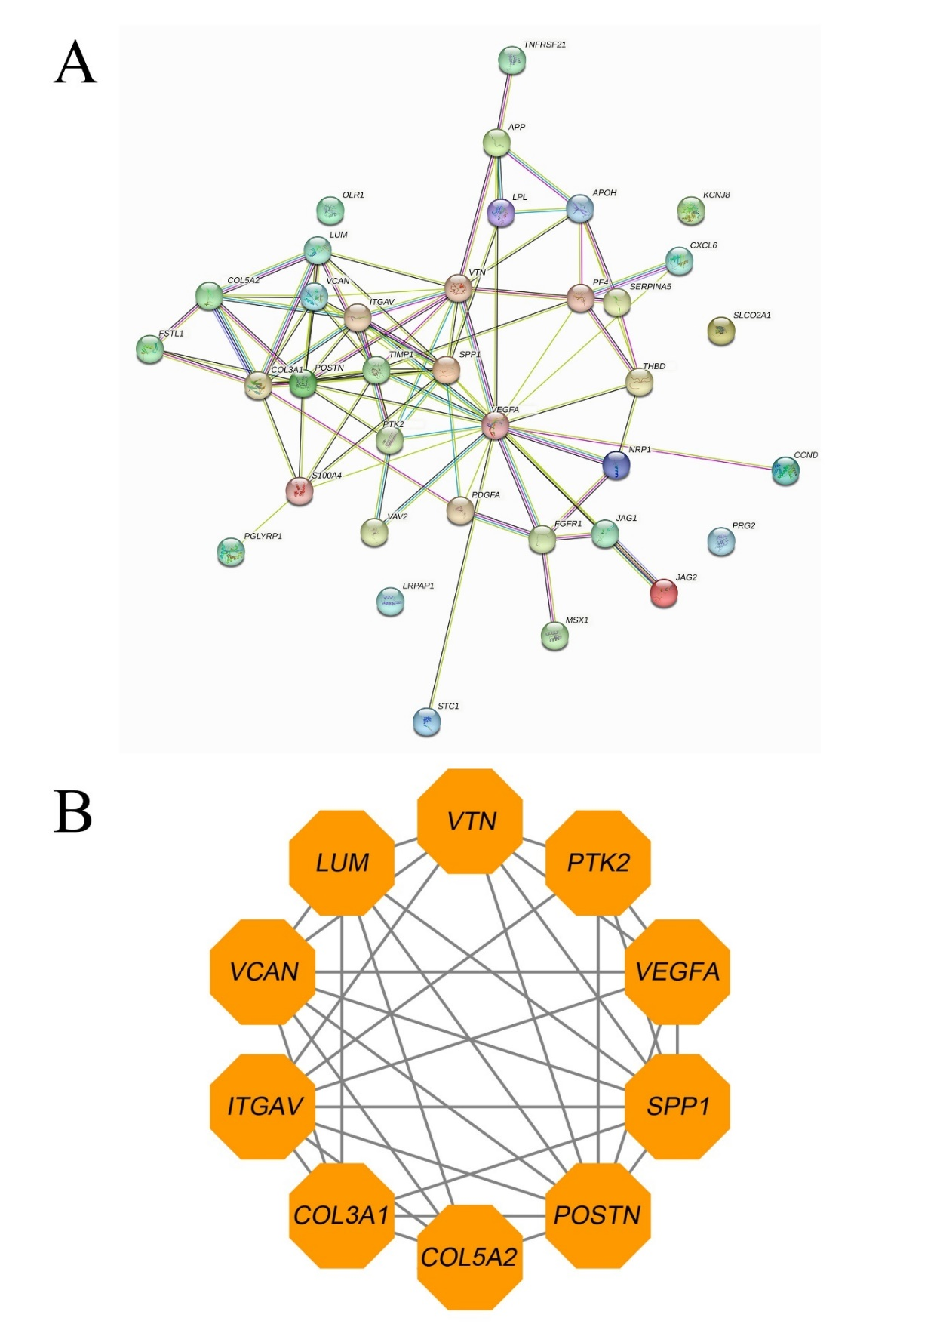
Figure 1 Interaction network of 36 angiogenesis-related genes in LUAD. A: STRING network diagram showing the interaction of 36 angiogenesis-related genes in LUAD. B: Key subnetwork and 10 hub angiogenesis-related genes.
Figure 2
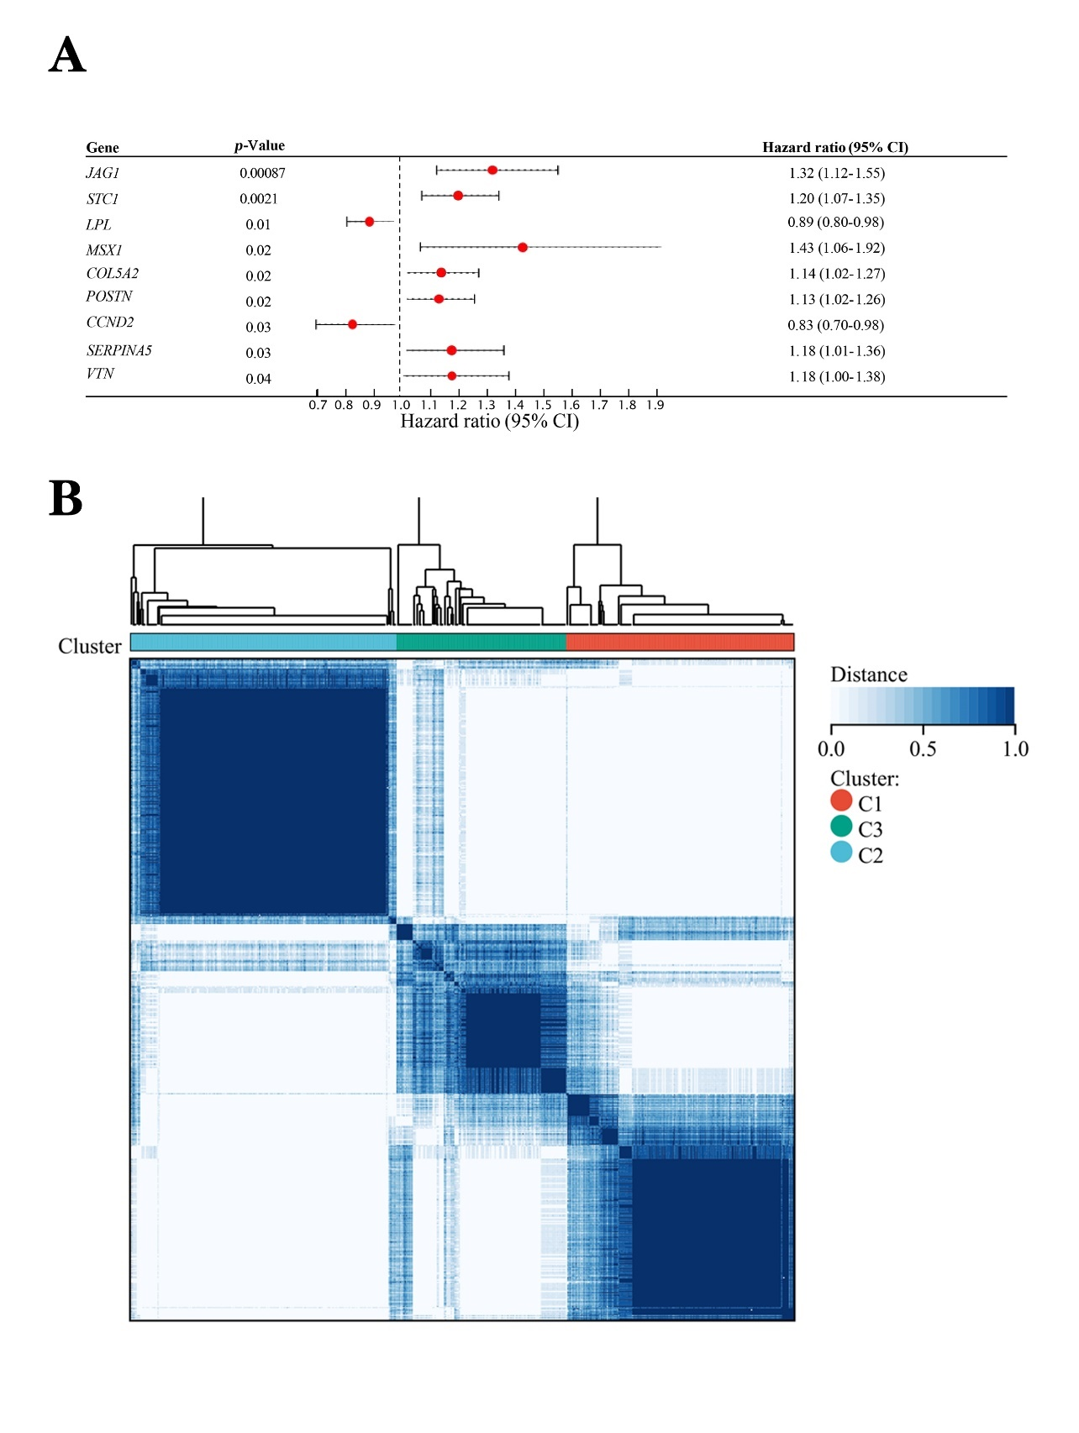
Figure 2 Prognostic-related angiogenesis-related genes and molecular subtypes in LUAD. A: Univariate Cox survival analysis identified 9 prognosis-related angiogenesis-related genes in LUAD. B: Heatmap of clustered angiogenesis-related genes subtypes (k = 3).
Figure 3
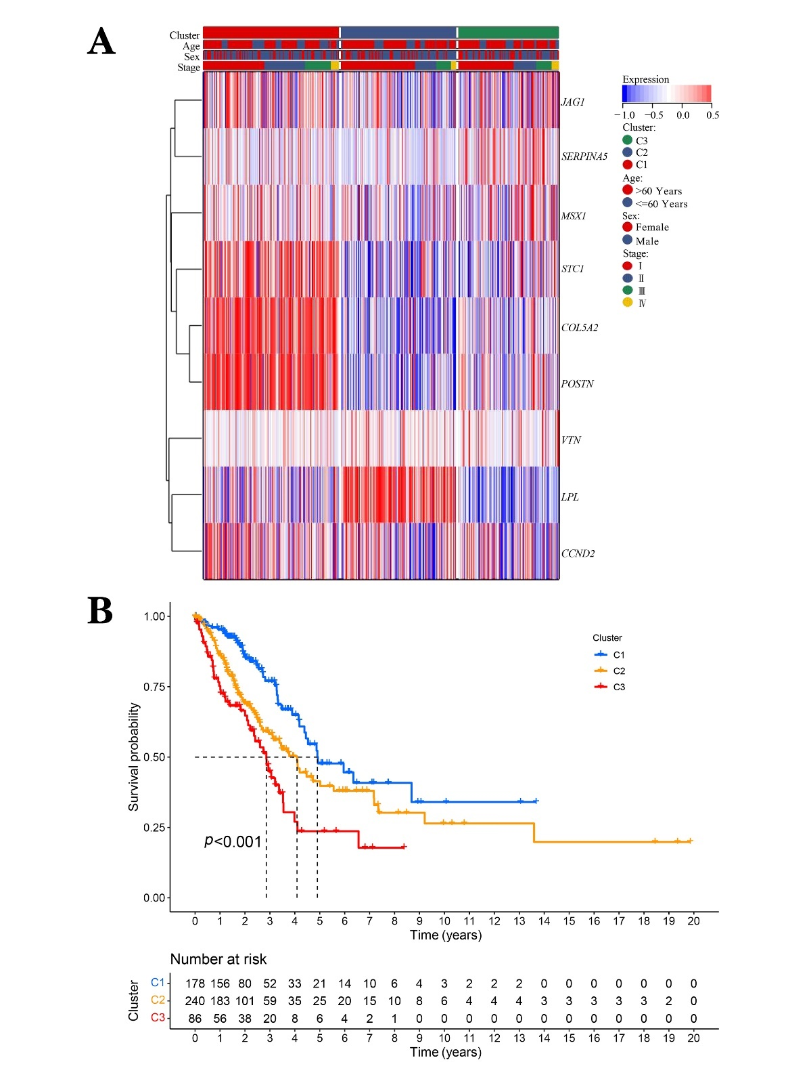
Figure 3 Survival analysis for molecular subtypes. A: Heatmap of expression of 9 prognosis-related angiogenesis-related genes in different molecular clusters (k = 3). B: Kaplan–Meier curves shows the difference in overall survival between different molecular clusters in lung adenocarcinoma(p<0.001).

Figure 4
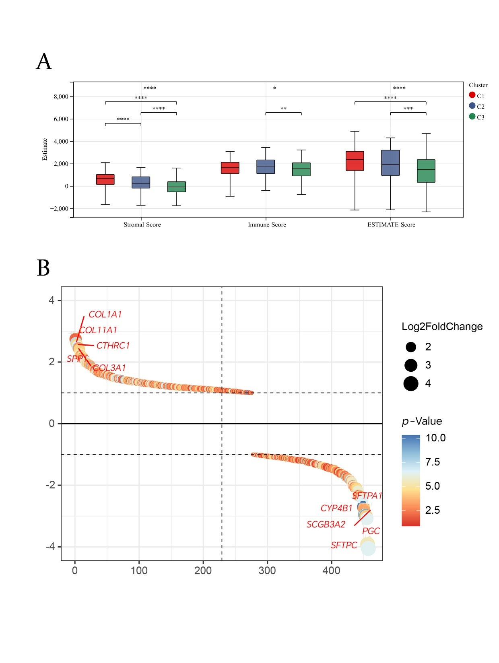
Figure 4 Estimate analysis among the three angiogenesis-related genes clusters. A: Differences in ESTIMATE scores among different clusters of lung adenocarcinoma. B: Plot ranking differential expression of differentially expressed genes among the three clusters. Significantly different at: *p<0.05,**p<0.01, and ****p<0.0001
Figure 5
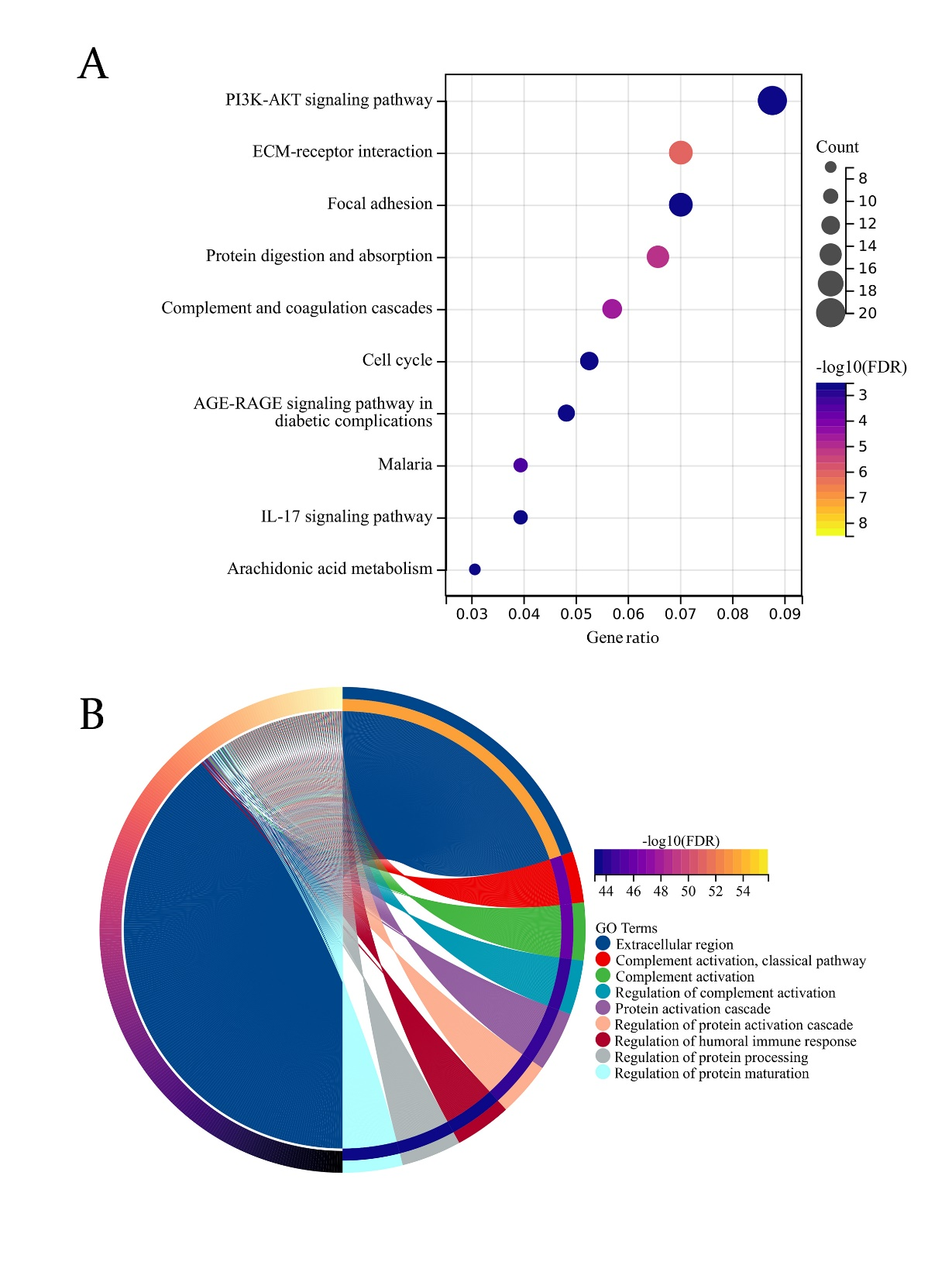
Figure 5 Functional enrichment analysis of differentially expressed genes between different clusters. A: Kyoto Encyclopedia of Genes and Genomes enrichment analysis of differentially expressed genes. B: Gene Ontology (GO) enrichment analysis of differentially expressed genes.
Figure 6
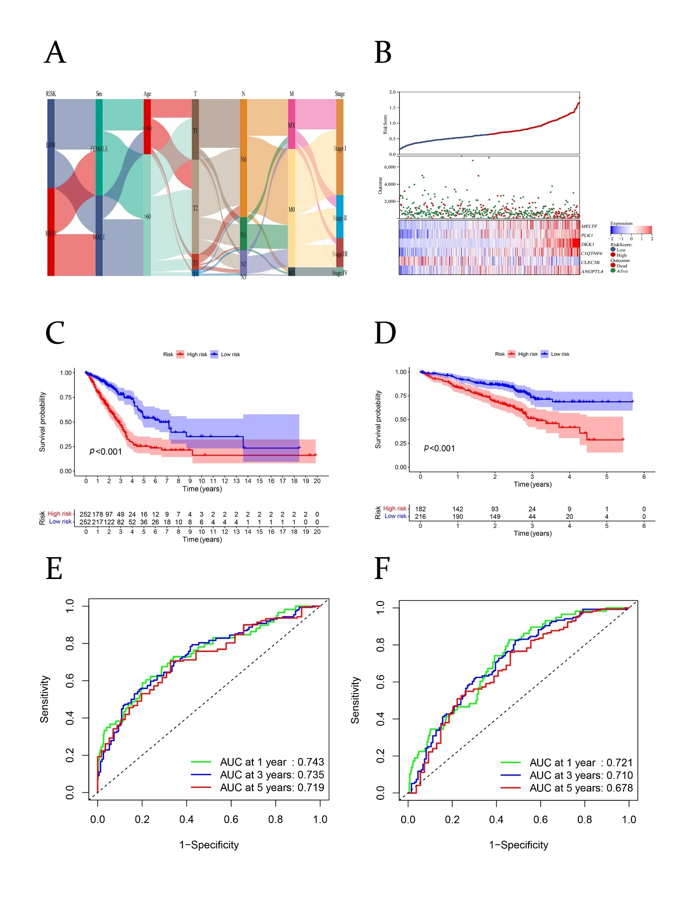
Figure 6 Construction of risk model. A: Sankey diagram of clinical characteristics in different risk groups based on the cancer genome atlas lung adenocarcinoma cohort. B: Survival was inversely associated with the risk score, and patients in the high-risk group and low-risk group tended to express different candidate genes. C: Patients with high-risk scores had worse overall survival (p<0.001). D: Kaplan–Meier curves for the GSE72094 cohort from the Gene Expression Omnibus database according to risk group (p<0.001). E: Receiver operating characteristics curve for the risk model. F: Receiver operating characteristics curve for the GSE72094 cohort.

Figure 7
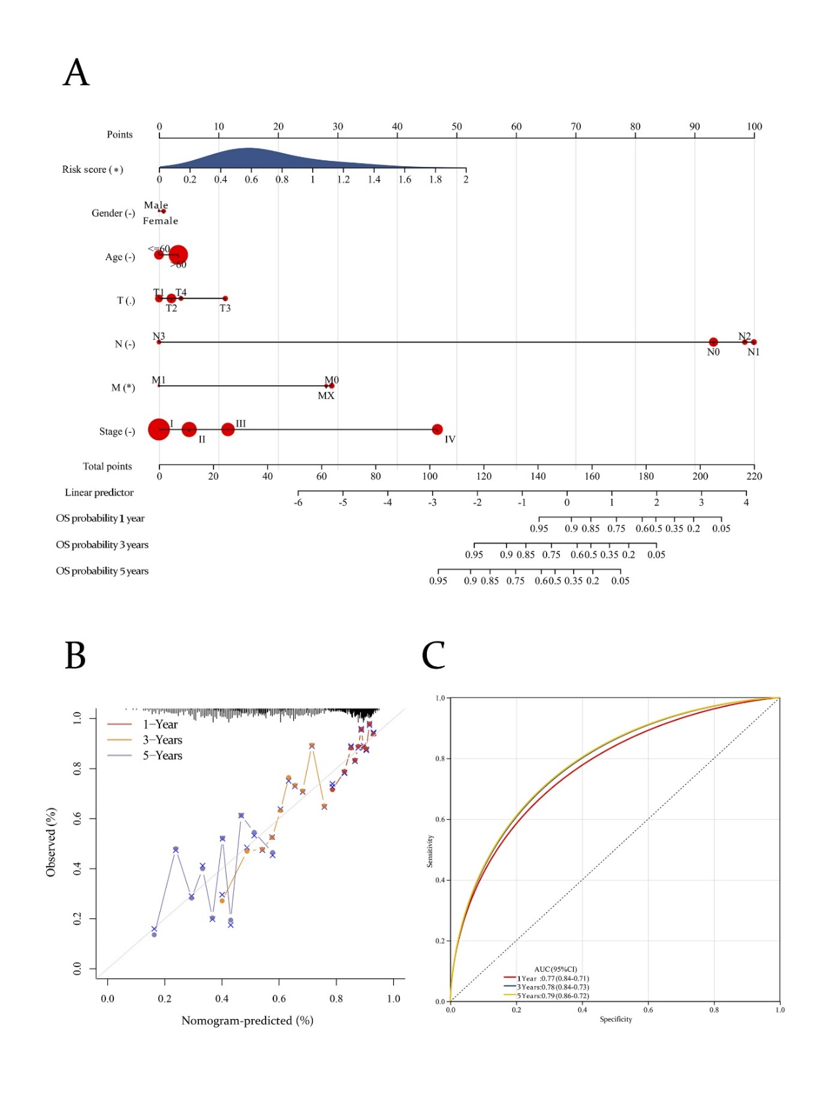
Figure 7 Establishment of a nomogram. A: Nomogram for predicting the 1-, 3-, and 5-year overall survival (OS) of patients with lung adenocarcinoma. B: Calibration curves for 1-, 3- and 5-year OS. C: Receiver operating characteristics curve for the nomogram.
Figure 8
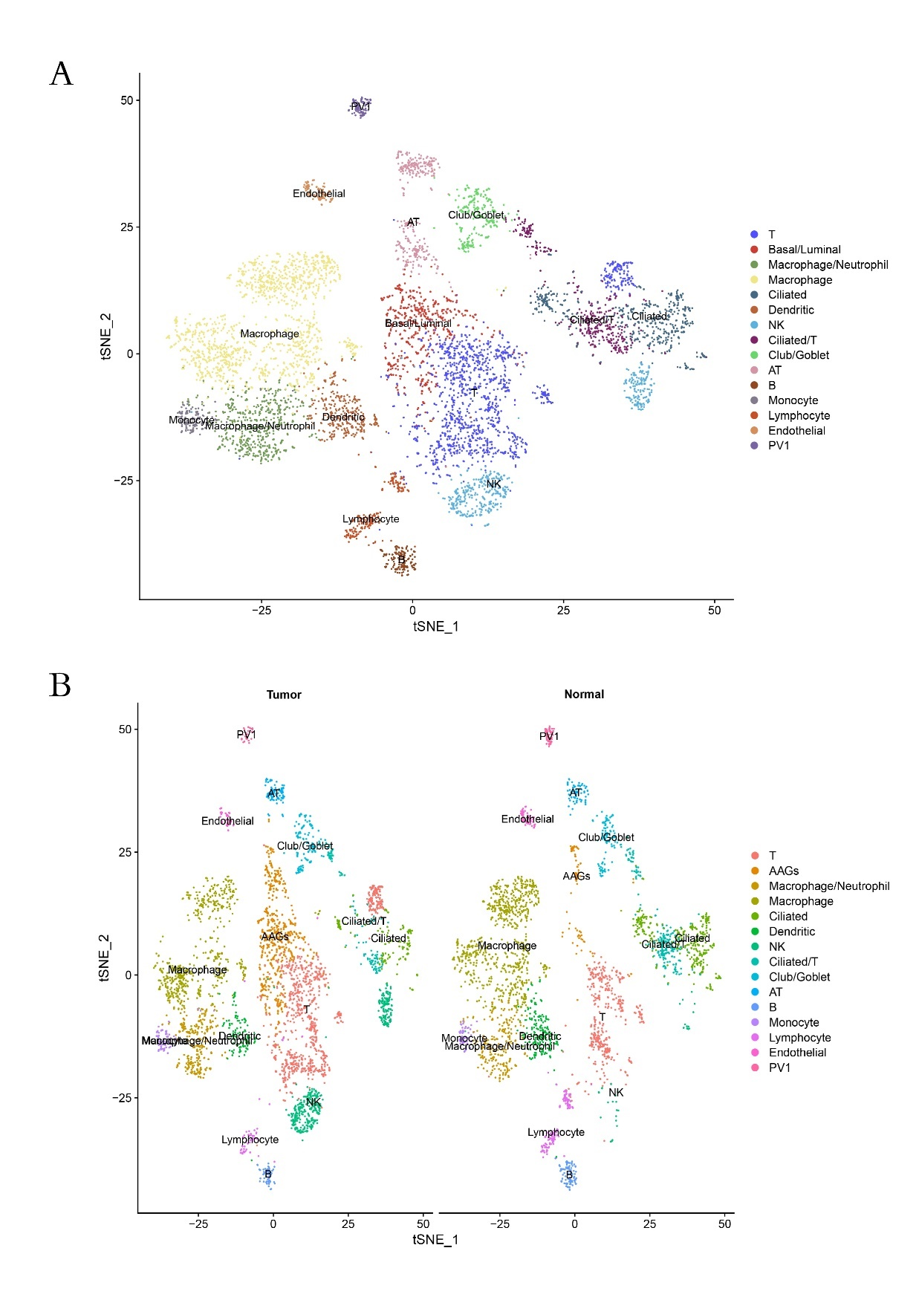
Figure 8 Single-cell sequencing analysis of lung adenocarcinoma and normal tissue. A: Cellular annotation of samples. B: angiogenesis-related genes were significantly overrepresented in Basal cells and Luminal cells.
Figure 9
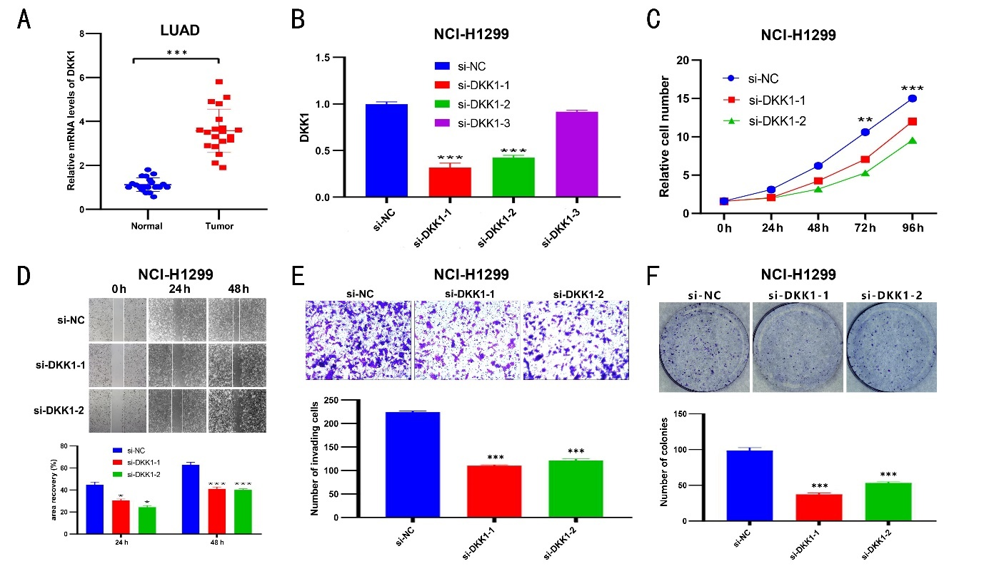

Figure 10 Verification of DKK1 function in lung adenocarcinoma.
A: Expression of DKK1 mRNA in LUAD and normal tissue of our samples. B: Reverse transcription-polymerase chain reaction verification of the knockdown efficiency of DKK1 in NCI-H1299 cells. C: Cell Counting Kit-8 assay to analyze the effect of DKK1 knockdown on cell proliferation. D: Analysis of the effect of DKK1 knockdown on wound-healing ability by scratch test. E: Transwell assay to analyze the effect of DKK1 knockdown on cell migration. F: Effect of DKK1 knockdown on cell clonal formation capacity. Significantly different at *p<0.05, **p<0.01, ***p<0.001.

Supplementary figure 1
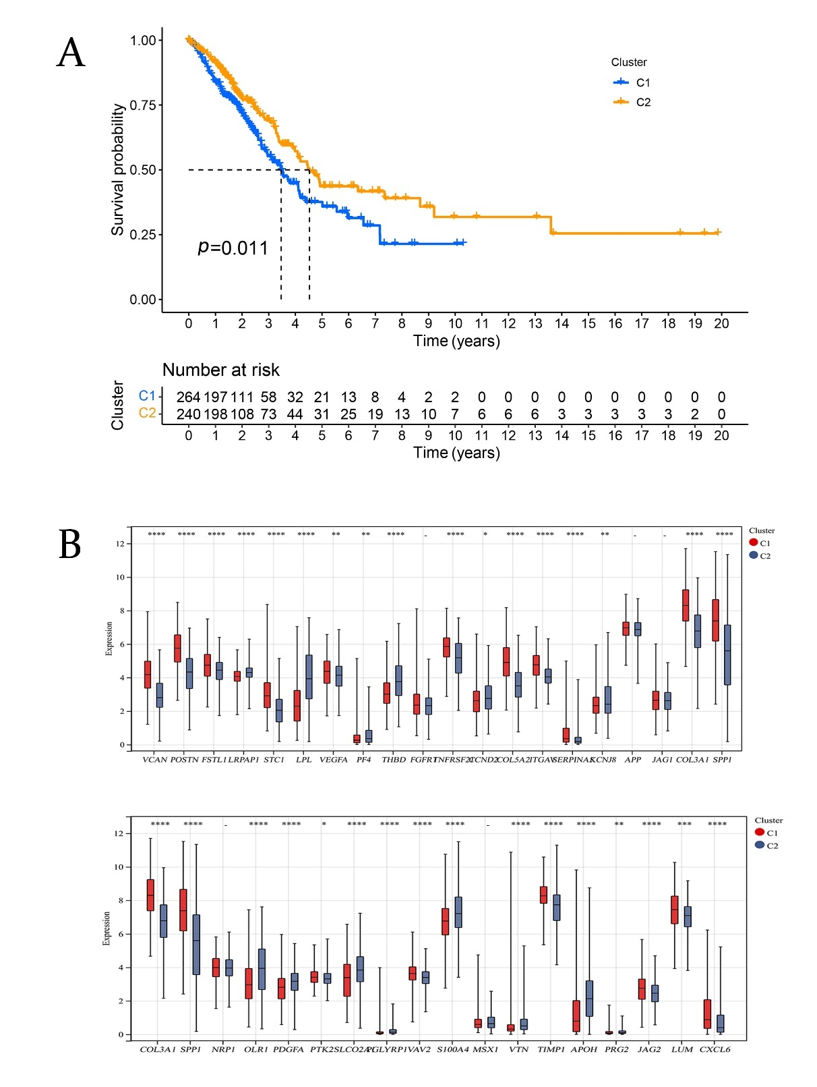
Supplementary figure 1 Retyping based on differentially expressed genes. A: Survival according to differentially expressed genes cluster. Patients in the two DEG clusters had significantly different survival (p=0.011). B: Differences in the expression of angiogenesis-related genes among the two differentially expressed genes clusters. Significantly different at *p<0.05.
Supplementary figure 2
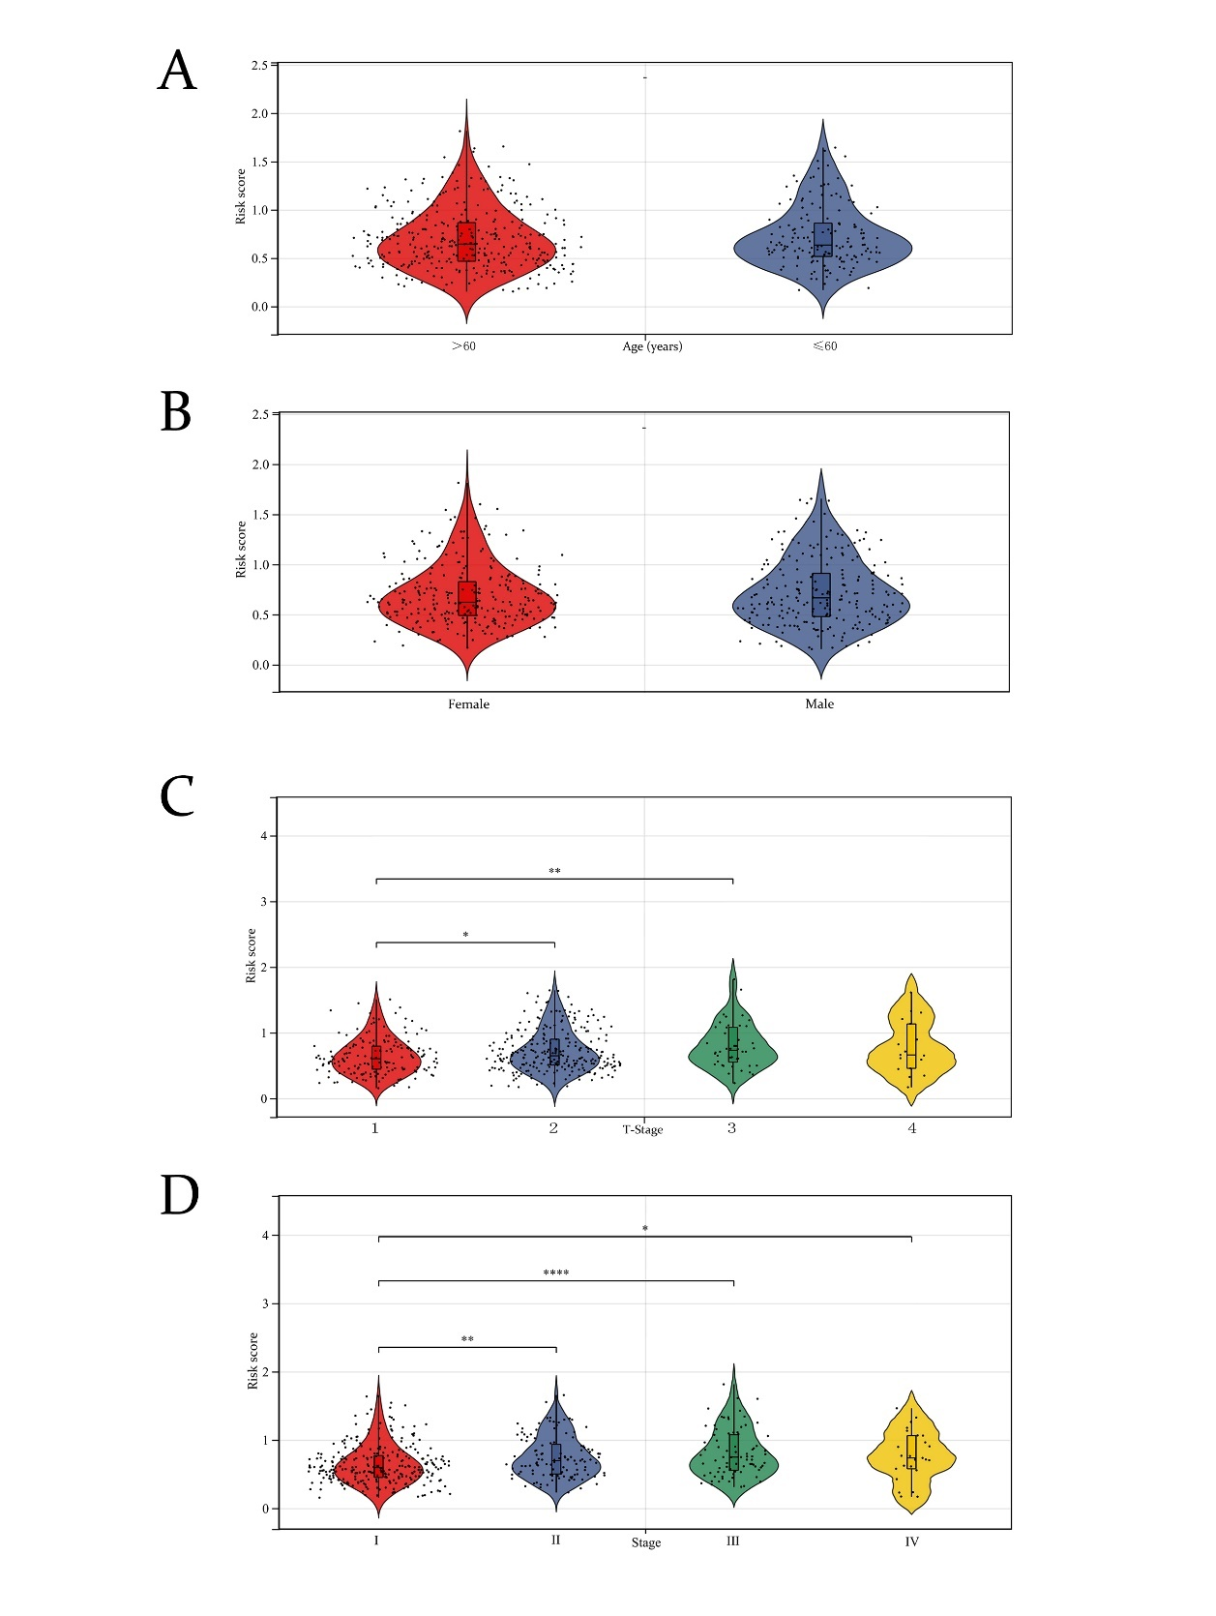
Supplementary figure 2 Correlation of risk score with clinical features. A: Differences in risk scores between ages. B: Differences in risk scores between sex. C: Differences in risk scores between tumor stages. D: Differences in risk scores between stages. Significantly different at: *p<0.05,**p<0.01, and ****p<0.0001.
Supplementary figure 3
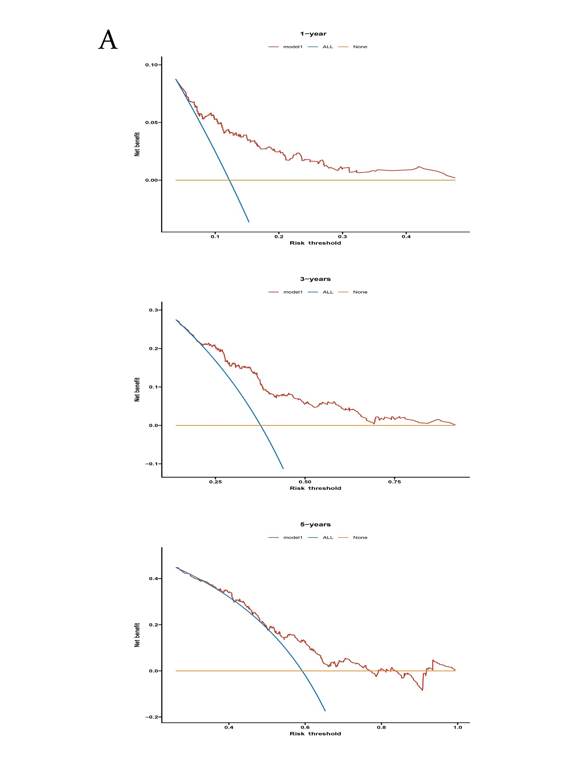
Supplementary figure 3 Decision curve analysis for the nomograms compared for 1-, 3-, and 5-year overall survival. Blue line represents all positive. Yellow line represents all negative.
Supplementary figure 4
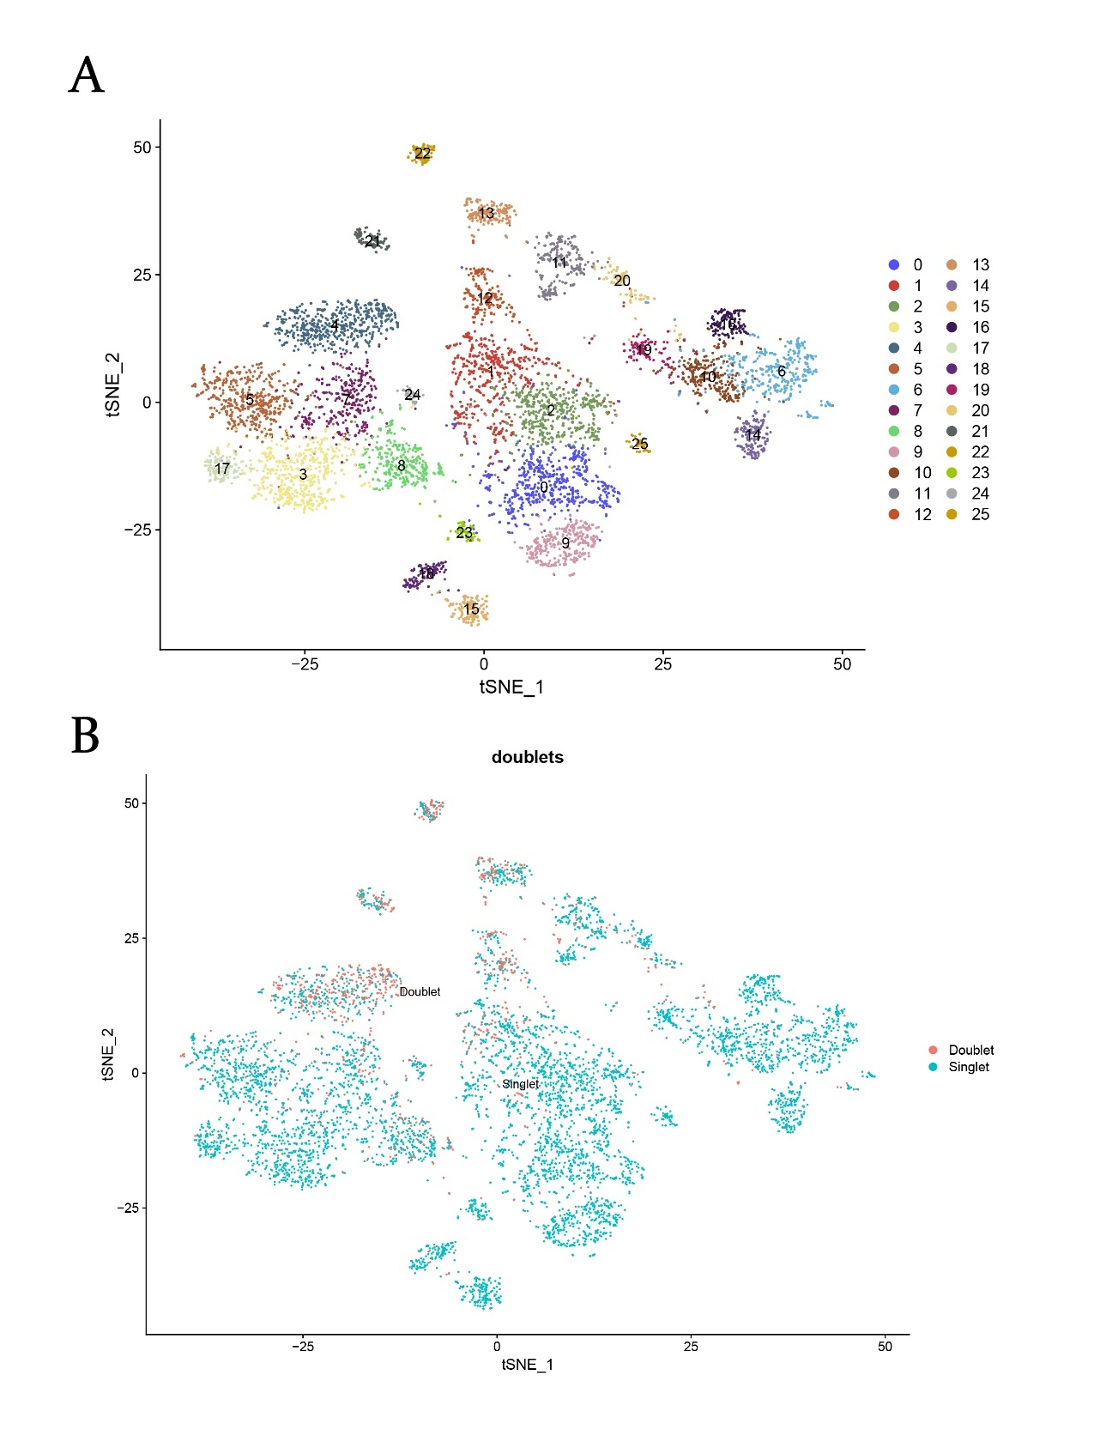
Supplementary figure 4 Clustering single-cell sequencing data of lung adenocarcinoma and normal tissue. A: Samples were clustered to 25 groups. B: Doublet versus singlet in samples.

Supplementary figure 5
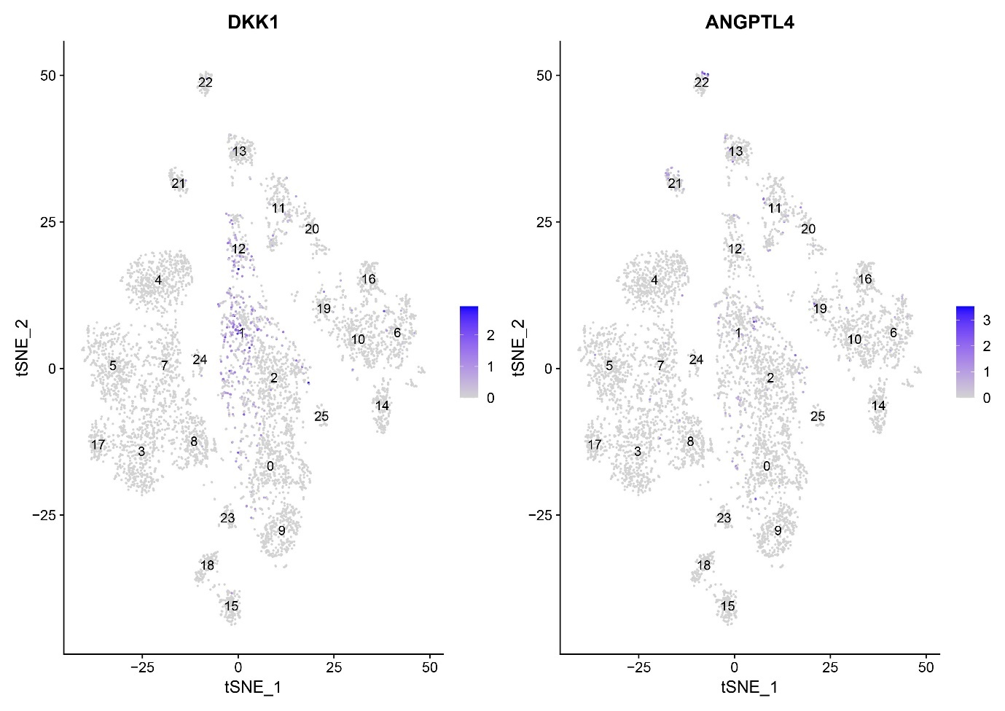
Supplementary figure 5 The predicted genes were significantly overrepresented in Basal cells and Luminal cells

Supplemental Table I ：51 differentially expression genes associated with survival

